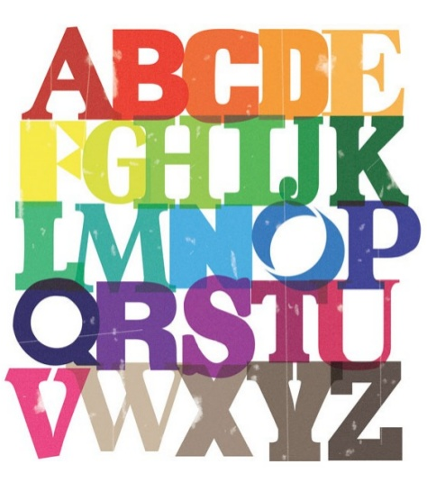 Year 1

Week Beginning: 09.01.17 Test: 13.01.17 Group: Mrs. Fairclough
Read, look, write, check and say.

Words: | Monday | Tuesday | Wednesday | Thursday
night
between
kitchen
beginning
started
does
were
one
said
they

